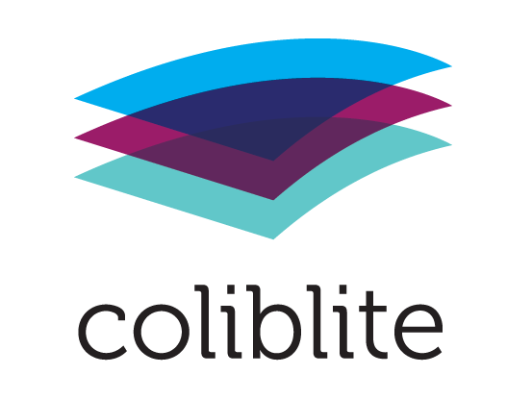

Local action plan Utrecht
Version of 19 November 2018

Table of content
1 Summary of COLIBLITE project + objectives 2
2 Findings from inventory activities 3
2.1 Demographic picture of the neighborhoods 3
2.2 Relevant national and local developments 4
2.3 Digital citizenship activities and policies of partners 6
2.4 Local partners 10
2.5 Digital citizenship policies and programs in schools 11
2.6 Existing horizontal cooperations 12
2.7 Digital competence of children and youngsters 13
2.8 Needs and demands of local partners concerning support and training 13
3 Terminologies 14
4 Planned results 15
5 Organizational structure 16
6 Horizontal and vertical activities 17
7 Dissemination in local multipliers meetings 19
8 Planning activities and results in year 2 - 3 19
9 Evaluation methods 19

Summary of COLIBLITE project + objectives

With children engaging with internet and digital technology on a regular basis, parents and educators are showing natural concern over young people’s online opportunities and risks. Many parents do not know where to access help and information, moreover, migrant families are at a further disadvantage because of limited access to information and language barriers. MLF adults and children alike do of course use mobile devices and computers. However, they often have limited knowledge and skills to make full use of these devises and are often not fully aware of the possible dangers in and while using them. Therefore, large segments of MLF children and youngsters are in danger to miss out on obtaining necessary basic ICT skills, digital information- and critical thinking skills, which are essential to follow proper education, to find a future place in the labor market and to participate as equal (digital) citizens in society. The lack of digital citizenship skills also makes them more vulnerable to the negative elements of the digitization of society like grooming, sexting, bullying, radicalization and polarization.

Children are living in “different worlds”.

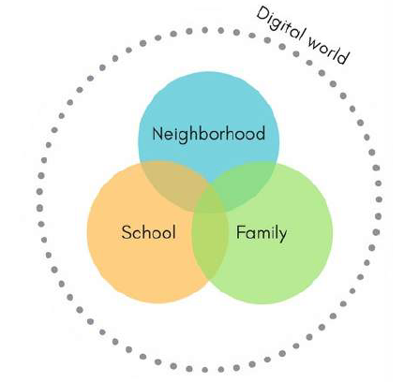
Organizations like community centers, libraries, schools, NGO’s and media education providers are increasingly dedicated to offering specific services to (MLF) families on digital education but do not necessarily have structurally integrated these elements in their activities yet. Also, school curricula and library services do often not pay enough attention to elementary digital citizenship skills. Teachers, youth workers and librarians often do not have the right (intercultural and digital) competences to support and coach MLF children, youngsters and their parents.

COLIBLITE promotes a horizontal neighbourhood approach to teaching (MLF) children and young people basic digital skills and digital citizenship. This approach encourages new working and cooperation methods between local actors and promotes the acquisition of digital skills and competences by teachers, librarians, youth workers and their institutions in order to provide them with the necessary skills to teach (MLF) children the necessary basic ICT skills, digital information- and critical thinking skills.

Findings from inventory activities

Demographic picture of the neighborhood Zuilen in Utrecht

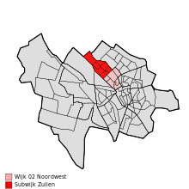

Of 24.000 people living In the Zuilen neighbourhood, 66% is indigenous Dutch and 34% has a migrant background. These 34% can be divided in Western, Moroccan, Dutch Antillean, Surinam, Turkish and others.

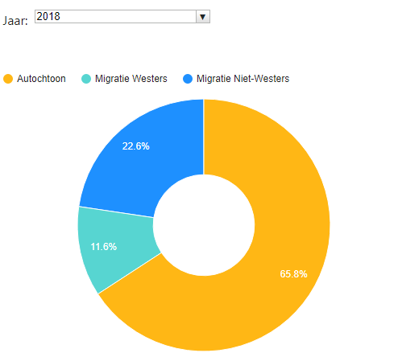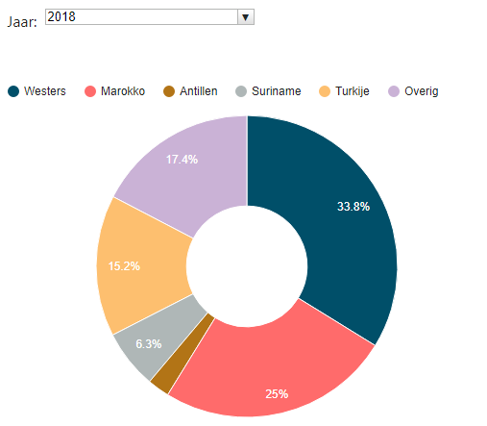

The income levels in Zuilen are:

High income: 11,4%
Low income: 57,8%

Relevant national and local developments

In Utrecht developments take place regarding digital citizenship and 21st century skills. In 2015 the Platform Intercultural Media Education (PIM) has been established by Mira Media, Stichting Al Amal, Stichting Vreedzaam and Utrecht Library. Together, they collaborate and focus on an integrated approach to intercultural media education in Utrecht and provide intercultural media literacy and education for schools, teachers, parents and children.

The municipality of Utrecht created the Platform Utrecht Education Agenda “Het platform Utrechtse Onderwijs Agenda (UOA)”. In UOA all educational levels (including the University) in Utrecht are represented, as is the municipality itself. The UOA formulates every four years a joint agenda for the educational sector in Utrecht. Important principle of the agenda is: learning is not only taking place in schools. Neighbourhoods, cultural- and social organizations and youthwork are all part of the development of talents with children and youngsters.
- Based on the UOA action program, the municipality of Utrecht supports innovative projects in schools and in neighbourhoods with various subsidies. Among which projects concerning digital citizenship.
- Local organisations and institutions in Utrecht are being encouraged by the municipality to take own initiatives and to work in partnership to introduce digital citizenship in all aspects of society.
- At present the municipality of Utrecht formulates in cooperation with UOA the action program 2019 – 2022. Efforts are being made by several parties to put “digital citizenship” more explicitly on the action program.
- Apart from the present urgency in schools, schools also must be prepared for the curriculum changes which will be introduced nationally in 2020 – 2021 in all schools. This means that the curricula will have to include four digital literacy skills: media literacy, ICT basic skills, computational thinking and information skills. The UOA action plan can support the schools in the preparation for these changes.

Digital citizenship activities and policies of partners
Inventory of present own involvement of local COLIBLITE partners in digital citizenship activities and 21st century skills, based on 6-cylinder methodology;
- Interviews in each partner organization with management, professional workers and volunteers

Bibliotheek Utrecht
The mission of Utrecht Public Library is helping people to read the world. In all languages, also digital. The Vision of the Library on Digital Culture is published in 2017 and is leading in the next years for all services. Media literacy and Digital Citizenship are important parts of the vision. Cooperation with other organisations in Utrecht is the main condition to create support and good results. The Utrecht Public Library has a long tradition in working with schools. Supporting schools with activities and books.

Pre-school: contributing on language and reading development. To improve the reading environment at the preschool and at home. Informing parents about media literacy and media education.
Primary school: there are lessons about several subjects:
- Increase the pleasure in reading
- Book promotion
- Information skills
- Media literacy for children, professionals and parents
Find your way in the Library is a program for children to learn how to find information in books and on the worldwide web in a smart way.
Secondary school: there are lessons about several subjects:
- Increase the pleasure in reading
- Book promotion
- Information skills
- Media literacy for youngsters, professionals and parents
Bieb escape is a playful program where working together leads to the right solution, searching and finding all kinds of information in books and online.
Factcheck dubbelcheck: geloof jij alles wat je leest?; don’t believe everything you read or see, what is the difference between fact and fiction. And how about social media?

To support informal learning the Utrecht Public Library programs activities, like:

Digital Laboratory
De Utrecht Public Library offers children in the Digital Laboratory a place to create, invent, share and develop knowledge. There is a Laboratory in Central Library. In the future there will also be Laboratories travelling around the city to libraries and schools. In the Laboratory children and their parents can work with electronics, software, robots, laser cutters and 3D printers.

Skoolzone
The skoolzone is a place in the Library where children have daily access to digital information in combination with books to make a presentation or a paper for school. There is always a librarian available for assistance.

Me’kaar
Me’kaar is the “social broker organization” (Sociaal Makelaar Organisatie) in Utrecht North West. Me’kaar supports if needed elderly and vulnerable people in the Utrecht NW area to active participation in the local society. It also strengthened local networks around MLF children, parents and professional educators in the area. Me’kaar collects and shares knowledge and expertise, connects social parties in the area and builds social networks. Me’kaar also supports local citizens in developing the personal skills. Me’kaar has a special by the municipality delegated task to support the schools and coordinate the cooperation between them. (Bredeschool coordination). In this role is closely corporates with the municipality, schools, external professionals, MLF parents and with Mira Media. Mira Media is a formal alliance partner of Me’kaar. They cooperate to introduce and implement digital citizenship in all aspects of Utrecht NW in cooperation with schools, health institutions, MLF communities, churches, mosques, etc. Me’kaar also has a Shared Service Centrum through which it facilitates schools with professional support concerning cultural and media literacy activities in and outside school hours.

Brede school Zuilen
Brede school Zuilen is a cooperation of primary schools in the Zuilen neighbourhood. The cooperation consists of the following schools: Prinses Margrietschool, de Cirkel and Wijzer aan de Vecht. The joint Brede school activities are being coordinated by Me’kaar.

Primary schools
The above mentioned schools committed themselves to participate in the COLIBLITE project. In COLIBLITE they will work on educational policies, training of teachers, participation of parents, improving the cooperation with external partners, integration of educational models on digital citizenship in their school programs.

Mira Media
Mira Media is a local center of expertise on media and diversity based in Utrecht. Mira Media operates as a link between media and multicultural society, as a “digital social broker”. It develops intercultural projects that are innovative in nature and are generally carried out with partners from different sectors of society. All Mira Media activities and projects are and have been related to media, diversity and media literacy. Mira Media is a non-profit organization it supports migrant groups and organizations in multicultural neighborhoods in using (digital) media in support of intercultural dialogue and citizenship.

Local partners
Inventory of existing other local (intercultural) activities and initiatives concerning 21st century skills for children

Utrecht youth work organization JoU
In 2017 -2018, the JoU foundation has adapted its policy to the changing (digital) working environment. The experiment Digital Citizenship focused on various components in social media:
- Working with young people: contacting and maintaining, recruiting / reaching, knowledge of the living environment and pedagogical work (signaling, stimulating healthy media use).
- Communication tool with parents / externals / internal
- Safe and professional media use (privacy, naming, workload, etc.)
- JoU (as an organization) visible on social media
- Pilot media literacy 10-14-year olds (2 groups of teenagers, 6 meetings per group).

Art. 1 Midden Nederland
Artikel 1 Midden Nederland is actively involved in the prevention and combating of discrimination and the social processes that underlie it. They see unequal treatment not as incidental and individual, but as a structural social phenomenon. All the activities carried out by Art. 1 MN contribute to an inclusive society in which everyone has equal opportunities (Art1middennederland.nl, 2018). They provide guest lessons to primary and secondary schools and engage with older children on the topic of cyberbullying. With the aid of videos, students begin to identify what cyberbullying is, what are the possible effects as well as what to do if it is happening to themselves or a friend.

Al Amal
Al Amal is an independent organisation that wants to promote the participation of families, mothers, women and youth within the Moroccan Dutch community. It focuses on those who may struggle to find their way in Dutch society on works on their own strengths. This organisation works according to the principles of the peaceful neighbourhood (Al-amal.nl, 2018). Regarding digital skills, the Al Amal Foundation offers three training programmes in the field of media literacy.

Digital citizenship policies and programs in schools
- Digital competence is increasingly becoming indispensable, an alarmingly high number of people however still lack a basic level of digital competence, putting them at risk of unemployment and social exclusion. This can contribute to creating a ‘digital divide’, which can lead to social and economic inequalities and which poses a clear challenge to our education and training systems.
- Media wisdom has prominently featured in the Netherlands since 2008, especially regarding the recommendations from the Council for Culture. However, media wisdom has not been integrated in the school curriculum despite the Council recommending this twice. The Dutch government planned a curriculum change in 2020 – 2021 which will finally introduce digital literacy in the national school objectives and attainment targets. This will have a major effect on the Dutch school programs in primary- and secondary education.
- Even though working on digital citizenship is not compulsory, there are various (ad hoc) initiatives that work locally on digital citizenship/digital literacy in the neighborhoods and schools. These initiatives show that Dutch schools at present are not well equipped to teach and coach pupils and students towards a full digital citizenship. There is also no feeling of urgency concerning the upcoming curriculum change in 2010-2021. Teachers need enough knowledge of media literacy, suitable teaching material or software and sufficient ICT facilities at school. Half of the teachers mention enough class time and support at school as an important precondition.
- In the Netherlands several national, regional and local support structures deal with different of aspects digital citizenship. However, each has its own responsibility and there is no national comprehensive vision and/or mission on digital citizenship. Schools and other local organizations are not obliged to obtain the services or advises from the existing structures. This makes it unclear for local professional workers/teachers 'what' is digital citizenship, who “owns it”. This contradicts and obstructs the local development of comprehensive "whole school" approaches involving the entire school community as well as other relevant stakeholders.
- In Utrecht local organizations have made substantial efforts to create a promising joint local infrastructure to support schools, parents and children/youngsters. This joint venture is still project based and not supported yet by municipal policies and policies of the school boards. Efforts are being made, in light with the upcoming curriculum change, to change this situation. The COLIBLITE project is anticipating on these developments by realizing a neighborhood approach based on the eight principles of the Council of the European Union.
- As a result of the DGGMLF project in Utrecht there is a quite dense network of educational support activities for parents concerning digital citizenship.

Existing horizontal cooperation’s
Digital citizenship education in Utrecht builds on existing pedagogical frameworks. In Utrecht, 75% of the school’s, in all Utrecht neighbourhoods, work with the citizenship programme the Peaceful School (De Vreedzame School). This is a citizenship program for primary schools on “offline” social competences and democratic citizenship. There is a similar approach at neighbourhood level: The Peaceful Neighbourhood (De Vreedzame Wijk). The Peaceful Neighbourhood focuses more on the parents and residents to devote more attention to the educational climate at home and in the public space. As the offline and online world of children are intertwined and because citizenship competences in both environments should be similar, Mira Media developed, in collaboration with local (Vreedzame school and Neighbourhood) partners, an integrated neighbourhood-oriented approach to promote digital citizenship by children (and their parents) aged 6-12. This approach aims at the cooperation of schools, libraries, neighbourhood organisations and parents. This approach involves inside- and outside school activities for children, meetings with parents and counselling of schools and professionals concerning the inclusion of digital citizenship in the educational and organisational mission and vision and the training of the educational professionals. The six Cylinder Model of Intercultural Media Education is the base of all these activities.

In Zuilen the schools a cooperation within the Brede school Zuilen. The jointly organize cultural out of school activities and take part in neighbourhood events.

Digital competences of children and youngsters
- Children and youngsters estimate their own digital skills much higher than they are. They also indicate that they learn their digital skills mostly out of school. There are big differences concerning digital literacy competences and skills between parents, between librarians, between youth workers and between teachers concerning individual motivation and their level and possession of digital literacy skills and competences.

Digital competences of professionals

Inventory: present competencies of educational, library and youthwork professionals
- Activities with professionals to investigate their questions, demands and their own digital skills and competencies.

In preparation of this plan of action interviews and workshops have been taken place with the management of the participating schools (8), social workers of Me’kaar (6), library professionals (5) and staff members of Mira Media (4). During these meetings the media competences of in total 23 professionals were discussed based on a prepared questionnaire.

- The urgency to pay structured and systematic attention to digital citizenship is felt
- Afraid of extra work pressure
- Competences of teachers vary
- Attention to ad hoc digital citizenship
- Not yet fully implemented continuous learning track ICT basic skills
- Called attention to parental involvement
- This school year a new school plan has to be written
- Upcoming curriculum change 2020 - 2021
- Attention to technology education
- Ask for teacher competence enhancement. This must be done “creatively and unburdening”.

Terminologies
COLIBLITE Netherlands defines digital citizenship as follows: ‘Digital citizenship in the context of education and upbringing is an integral part of democratic citizenship. Digital citizenship can be defined as the willingness and ability of children and youngsters to participate actively and democratically in the online environment. Not only do they acquire knowledge, but they also learn to develop skills and attitudes that enable them to be an active part of society, both offline and online. Democracy, participation and identity are important elements in the formulation of citizenship, but they also have a digital component (Zwanenberg & Pardoen, 2010). Citizenship, and hence digital citizenship, thus becomes a moving concept that is attuned to the resources and (technical) developments in society.’

COLIBLITE Netherlands uses the Kennisnet and SLO model of 21st century digital skills which has been accepted by all Dutch ministries and major support networks. This model includes 11 skills that students will need in future. These skills include four digital literacy skills: media literacy, ICT basic skills, computational thinking and information skills (Kennisnet, 2017a). Both SLO and Kennisnet are translating these skills into materials and resources that schools can use in practice.

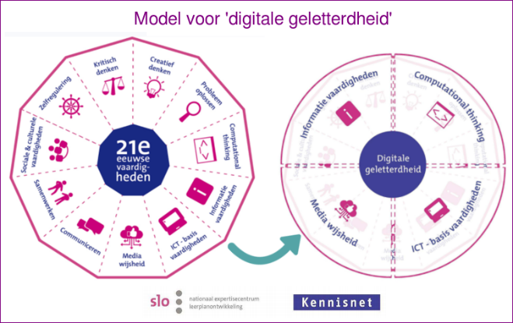

Planned results
COLIBLITE aims to develop horizontal coordinated neighborhood approaches, methodologies and actions involving schools, libraries, youth work, community centers and MLF parents to promote and teach the necessary digital citizenship skills, including: basic ICT skills, digital information- and critical thinking skills, with MLF children and youngsters. As children and youngsters of all ages use digital tools of some sorts, COLIBLITE will take a "vertical" perspective on digital competence development. In order to successfully deliver and implement the new methodologies and actions educators should be made aware of practices and problems faced by children and youngsters, should be able to work with horizontal competence schemes on digital- and citizenship skills and should obtain the needed intercultural- and digital citizenship competencies and skills themselves. COLIBLITE realizes these goals in transnational cooperation and by using all available local expertise and knowhow of participating partners, in order to prepare MLF children and youngsters for future labor markets and digital citizenship and to avoid a further digital and social divide in society.

Material results
- National research reports (IO 1)
- Local action plan, based on organizational commitments and horizontal neighborhood action plans (IO 2)
- Training intercultural digital and community competencies and skills of library professionals IO3
  - Training intercultural digital and community competencies and skills of local teachers and other educational professionals. IO3
  - Training + coaching programs intercultural and digital skills for MLF parents.
  - Joint training and coaching on horizontal cooperation in the neighborhoods
- Additional digital citizenship programs for children and youngsters in addition to the school programs and school curricula (IO 4)
  - Basic ICT skills programs (21st century skills) with children.
  - Digital citizenship skills with youngsters.
- Evaluation (IO 6)

Immaterial results
- Local horizontal cooperation between schools, libraries, youth work, community centers and MLF parents
- Implementation digital citizenship and digital 21st century skills programs in school- and library programs
- Upscaling of pilot results to other neighborhoods and cities
- Implementation + dissemination of local action plans
- Dissemination of COLIBLITE results.

Participants
The project is based on a local partnership, consisting of 2-3 formal COLIBLITE partners a “leading partner” + a school and a library in combination either with a community center and/or a youth work organization. These partners will be involved and responsible for Year 1 and Year 2. All formal partners take part in transnational meetings and working visits and transnational development activities. The local partnerships may be extended during the project period with new associated partners. In Year 3, new participants will be selected by the local COLIBLITE partners as part of the up scaling and implementation process.

In each stage the following learners, staff and stakeholders are involved: management of local partners; teachers; librarians; youth workers; volunteers; MLF parents; MLF children and MLF youngsters. In the year 1 – 2, most of these participants belong to or are connected to the local COLIBLITE partners. In year 3, similar professionals and MLF parents, children 4 – 12 will be involved as part of the up scaling and implementation activities.

Total participants
Year 1 50
Year 2 100
Year 3 200
Total 350

Organizational structure

- Management committee: members, frequency, role and responsibilities

  - The management committee meets twice a year
  - The management committee consists of the directors of the COLIBLITE partners: Bibliotheek Utrecht, Mira Media and Me’kaar.
  - The management committee discusses the national interim report.
  - The management committee oversees the progress of the project, the implementation in their own organizations and is financial responsible for the project

- Project group: ad hoc working groups which plan and organize specific activities

  - The COLIBLITE project group meets every four weeks.
  - The COLIBLITE project groups consists of the COLIBLITE project workers of the partner organizations.
  - The COLIBLITE project groups discusses:
  - The local plan of action
  - The evaluation of the COLIBLITE activities over de last four weeks
  - The horizontal cooperation
  - The support activities for the schools
  - Local developments
  - The planning of future activities (next four weeks)
  - Transnational cooperation

Ad hoc working groups on:
  - Development horizontal training
  - Development of vertical training
  - Development of programs for children
  - Parent participation

- Organization of periodical feedback and input from parents, children and professionals

Roles and responsibilities partners

Partner | Role | Responsibilities
Bibliotheek Utrecht | Project leader, local partner, participant in COLIBLITE project groups | Implementation of digital citizenship in library organization and programs. Development of - and offering information skills programs for children, inside and outside school, providing homework facilities, providing a Medialab program inside and outside school
Mira Media | Local coordinator, participant in COLIBLITE project groups | Coordination and management of development processes, facilitating the horizontal cooperation and offering digital citizen activities to children and parents outside the regular school hours. Coaching of school managements
Me’kaar | Local partner, participant in COLIBLITE project groups | Implementation of digital citizenship in organization and programs. Facilitating outside school programs for children and co-responsible for parent participation programs
Schools | Local partner | Implementation of digital citizenship into all aspects of the school organizations.

Horizontal and vertical activities

- Development and execution of training programs for professionals IO3

Transnational (MRC-London transnational coordinator)

- Transnational and local agreement on joint digital competence framework for educational professionals
- Development of (joint) training programs for librarians, teachers and youth workers of local COLIBLITE partners;
- Piloting and evaluating developed training programs
- The draft programs will be transnationally exchanged and discussed by Skype.

National

Piloting and evaluating developed training programs
- A training for trainers will organized to introduce the trainers to the final training package.
- At the end of Year 2 the entire process will be locally and transnationally evaluated, and the strategies will be adapted. The first results will be presented in a local multiplier meeting.

- Development and execution of activity programs for children and youngsters IO4

Transnational (AW-Bucharest, transnational coordinator)

- Transnational and local agreement on joint digital competence framework for children and youngsters.
- Formation of local horizontal steering group which will monitor and describe the progress of the pilot.
- The draft programs will be transnationally exchanged and discussed by Skype.

Development will be linked to already existing cooperation programs between schools and libraries. The activities with youngsters will, where possible, be linked to existing citizenship programs and/or anti radicalization and polarization programs.

National

Piloting and evaluating developed programs in libraries, by youth workers and with external media coaches in out of school programs of primary schools

- Development of (horizontal) vertical digital citizenship programs for children and youngsters in addition to the school programs and school curricula programs for MLF children and youngsters.
  - Basic ICT skills programs (21st century skills) with children in libraries
  - Digital citizenship skills with youngsters in libraries and youth work.
- A training for trainers will organized to introduce the trainers to the final educational package.
- At the end of Year 2 the entire process will be locally and transnationally evaluated, and the strategies will be adapted. The first results will be presented in a local multiplier meeting.
- Draft handbook on how to cooperate in a horizontal way in neighborhoods.

- Possible vertical activities

  - Development of own digital citizenship policies by each partner

- Direction and ownership at the school
- It is in line with the internal structure, wishes and pace of the school
- COLIBLITE works relieving and supporting
- Collaboration between schools only on common points
- Project consultation is limited in time as much as possible and has the character of a work meeting.

  - Support of school and youth organizations in developing own digital citizenship policies

General offer
- Support in formulating the objective and action plan Digital Citizenship / Digital literacy (possibly linked to the development of the new 4-year plan)
- Support with adjustment of mission and vision + determination of the policy consequences for the school (possibly linked to the development of the new 4-year plan)
- “Retrieving the demand” from teachers, the elderly and students
- Organization of internal expertise promotion (as part of Quick Win, media coaches accompanying the lesson, part of a study day, individual conversations with teachers, etc.)
- Development, purchase of teaching modules based on identified wishes within a school.

Specific offer per school (so far)
- Guidance during the implementation of the continuous learning pathway ICT Basic Skills (Wijzer aan de Vecht)
- Supervision of activities in the parents' room (the Circle)
- Will follow (Princess Margriet school)

  - Execution of activity programs with children and/or youngsters

Inside school program
- Guest lesson Information Literacy, at school and in the Library
- Traveling Laboratory (programming, making and discovering new technologies), Zuilen Library, at school and in the Library (from Wednesday 21 November 8 weeks in Zuilen)
- Bredeschool offer including Vlogging and Blogging
- Media coaches in the classroom (continuous by appointment)
- Activities in the Week of Media Literacy (16 - 23 November 2018)
- Consultation about coordination of possible other external offerings

Outside of school program
- Library offers outside school for children:
  - UP projects Homework places
  - Traveling Lab
  - Skoolzone

  - Execution of activity programs wilt MLF parents

- Information to parent groups in parental rooms, work locations and Library (Me'kaar and Mira Media)
- Cyberparent training (Me'kaar and Mira Media)
- Digital skills course for parents (Mira Media, Digiwijs, Library)

Dissemination in local multipliers meetings

Yearly local multiplier event
- Digital newsletter

Planning activities and results in year 2 – 3
Year 2 | Establishment local partnerships | Planning
 | Establishment of action plans for each partner organization and joint action plan | September - December 2018
 | Method development of school programs and supporting library programs for children and youngsters | October 2019 – June 2019
 | Training of trainers | March – June 2019
 | Training en coaching librarians | March – June 2019
 | Training en coaching teachers and other educational professionals | March – June 2019
 | Training en coaching parents | March – June 2019
 | Execution of 21st century programs for youngsters in local libraries, NGO's and schools in cooperation with parents | February – June 2019
 | Local evaluation based on 6-cylinder method | June 2019
 | Local multiplier event | July 2019
 | 3-day Transnational COLIBLITE Academy + working visit, London | June 2019
Year 3 | Implementation + dissemination stage | Planning
 | Adaptation + further implementation of local action plans
 | Establishment of action plans for each partner organization and joint action plan
 | Local training scheme for professionals, volunteers and parents in other neighourhoods
 | Training en coaching librarians
 | Training en coaching teachers and other educational professionals
 | Training en coaching parents
 | 21st century programs for youngsters in all local libraries in cooperation with schools and parents
 | Upscaling of methodologies to other local libraries and neighborhoods
Year 3 | Dissemination + exploitation stage | Planning
 | Local multiplier event
 | Transnational Toolkit
 | Transnational webinars
 | 3-day Transnational COLIBLITE Academy + working visit, Bucharest

Evaluation methods
- A simple assessment tool will be developed to assess, before and after the COLIBLITE experience, the information literacy competences of the children involved in the activities at the Marconi school. For the definition of the assessment tool, it is envisaged to involve the pupils who already developed such skills in the school year 2017/18 and who will produce the “video pills” to “transfer” the main findings from that experience to the other pupils
- A digital storytellling of the COLIBLITE experience will be developed, always with the involvement of the Marconi pupils, in order to document its progress and results and to produce communication material about the activities for public dissemination and promotion events, including parents
- In-depth reflection dialogues will be carried out with a few students, the teachers and other actors involved, again to produce content for the promotional video and to identify and explore also critical aspects, in view of the future replication of the experience at Marconi and/or other schools.

APPENDIX
- ICT-basisvaardigheden
Leerkrachten kunnen:
 | Goed | Voldoende | Matig | Onvoldoende
… met het digibord omgaan.
… digitale apparaten (doelgericht) in hun les verwerken.
… met browsers zoals Google omgaan.
… met programma’s als mail, PowerPoint, Excel, Word omgaan

- Mediawijsheid vaardigheden
Leerkrachten weten:
 | Goed | Voldoende | Matig | Onvoldoende
... hoe media gemaakt en gekleurd kunnen worden
… wat zij moeten/kunnen doen in geval van cyberpesten, sexting, etc.
… hoe je kunt reflecteren op eigen mediagebruik
… wat de voor- en nadelen kunnen zijn van (social) media

- Actuele kennis van digitale ontwikkelingen
Leerkrachten zijn op de hoogte van ontwikkelingen op het gebied van …
 | Goed | Voldoende | Matig | Onvoldoende
… nieuw lesmateriaal op het gebied van mediawijsheid
… het online gedrag van kinderen
… fake news/complottheorieën
… cyberpesten
… sexting

- Mogelijkheden tot scholing en onderlinge coaching
 | Goed | Voldoende | Matig | Onvoldoende
Leerkrachten krijgen bijscholing bij het gebruik van digitale leermiddelen.
Leerkrachten krijgen bijscholing/ voorlichting over (social) media gebruik van kinderen

MLF: Migrant- and Low educated Families
In the EU, 40% of citizens have no or low digital skills, whereas around 90% of jobs are estimated to need at least some level of digital skills in the EU. Acquiring those skills is thus rapidly becoming a precondition for workers to become and remain employable.

