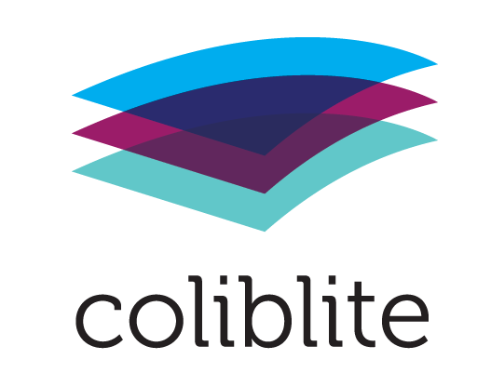

Joint local action plans involving library, school and youth work

The present involvement with digital citizenship and 21 century skills of each local project organization will be analyzed in the second part of Year 1. To do this all partners will use the 6- cylinder methodology. With this methodology schools, libraries and youth work will map they are involved in teaching digital citizenship skills and competences as well as 21st century skills and areas they still must work on. It offers information of each partner on:

- Vision & policies;
- MLF parent involvement;
- Digital competence of professionals;
- Existing cooperation with external neighborhood organizations;
- Age groups being targeted
- Exiting digital citizenship and 21st century skills activities.

Based on these reports, separate groups in and around the organization will be interviewed and asked for their opinions, dreams and foreseeable obstacles. Target groups are: MLF parents, educational professionals (librarians, teachers and youth workers), and management. MLF Children and youngsters will be interviewed indirectly as part of a media education activity.

The organizational reports will be jointly evaluated in the local partnership. Based on the outcomes partners will look for “horizontal” similarities, development issues, ways to support each other and discuss joint initiatives. In addition, attention will be given to wishes and needs of school, libraries and youth- and other social partner organizations considering “vertical” development of digital competences of children, youth and professionals.

This should result in a local action plan with development issues, training packages for professionals and pilot activities with MLF children, youngsters and parents. The local action plan will also consider the findings in the national reports like expected national trends and existing Digital Competence frameworks to be in line with national policy developments.

Based on the local action plan each partnership will develop an organizational local infrastructure which will plan, monitor and evaluate the execution of the local action plan and the horizontal cooperation. At the end of Year 2 the entire process will be evaluated, and the strategies will be adapted. The first results will be presented in the second local multiplier meeting.
Format local action plan

Work process

The local action plan is the basic element of the COLIBLITE project. It should be based on the cooperation between the three educational environments: family, school and street (neighborhood). In this project in each local partnership the family will be represented by the MLF parents, the school by one or more schools, the street /neighborhood by youth workers and the library acts as an in-between between school and neighborhood.

Step 1 – 4 are necessary steps to be taken in preparation of the local action plan.

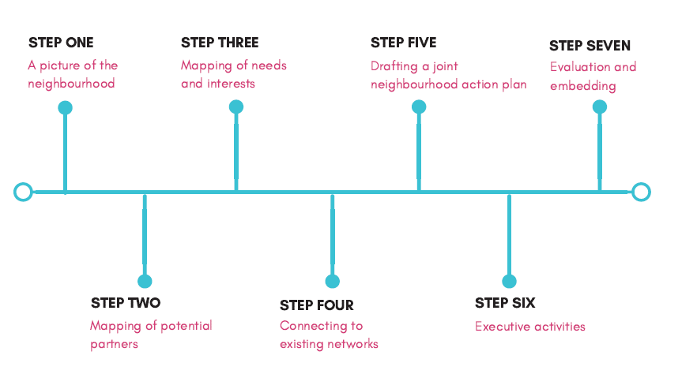
The following activities were foreseen in the COLIBLITE action plan:
- Inventory of present own involvement of local COLIBLITE partners in digital citizenship activities and 21st century skills, based on 6-cylinder methodology;
    - Interviews in each partner organization with management, professional workers and volunteers
- Inventory of existing other local (intercultural) activities and initiatives concerning 21st century skills for children
- Desk research and additional interviews
- Inventory: present competencies of children, parents, professionals
  - Activities with children and youngsters to investigate their digital skills and competencies.
  - Activities with parents to investigate their questions, demands and their own digital skills and competencies.
- Inventory: present competencies of educational, library and youthwork professionals
  - Activities with professionals to investigate their questions, demands and their own digital skills and competencies.
- Inventory of present urgent questions, “white spots” and “weaknesses”
  - Conclusions based on interviews and activities

Content local action plans

- Summary of COLIBLITE project + objectives

The COLIBLITE project aims to develop horizontal coordinated neighbourhood approaches, methodologies and actions involving schools, libraries, community organisations and parents.

The children’s activities aim to promote and teach the necessary digital citizenship skills such as ICT skills, digital information and critical thinking skills.

Educators (teachers and librarians) will become more aware of practices and problems faced by children and youths in the digital world. They will develop some skills to enable them to work to address them in their work settings, and in collaboration with other community partners. These skills will revolve around digital and citizenship competencies.

- Findings in step 1 – 4 concerning:
  - Demographic picture of the neighborhood
  - Relevant national and local developments
  - Digital citizenship policies of partners
  - Possible additional partners
  - Digital citizenship policies and programs in schools
  - Existing horizontal cooperation’s
  - Digital literacy competences professionals, children and youngsters
  - Needs and demands of local partners concerning support and training

A picture of the national and local context with regards to digital citizenship skills and competencies has been developed and put together in the UK National Report. The report looks at the different roles of schools, libraries, other organisations and government in shaping digital citizenship skills and tries to identify some of the gaps. Please refer to the COLIBLITE’s UK National Report for more detail.

- Terminologies

Definitions of ‘digital citizenship’ as adopted and applied by different actors in the neighborhood are discussed in the COLIBLITE UK National Report. Throughout the course of our investigations we have come to agree that the term ‘digital citizenship’ is still too broad to be understood comprehensively by the general public, and can lead to some confusion. Since the project is also creating new forms of dialogue about the topic of digital citizenship, this local action plan proposes that the term shall be broken down into more specific themes such as during the training.

- Existing competence schemes which will be used as base for local training and school programs (see attachment Digicomp)
We have looked at several existing competence schemes. The ones that have influenced the development of our action plan the most are:
- The UK Essential Digital Skills Framework
- The DigComp – European Digital Competence Framework

The following tools have informed the development of our training and action plan:
- The Digital Competency Wheel

- Planned results

The activities of the COLIBLITE project aim to improve the digital competencies and digital citizenship skills of children, youths, parents, educators and librarians.

We have developed more specific learning objectives for each training programme, which we will monitor to evaluate the impact.

- Organizational structure:
- Management committee: members, frequency, role and responsibilities
- Project group: ad hoc working groups which plan and organize specific activities
- Organization of periodical feedback and input from parents, children and professionals

Migrants Resource Centre | African Community School | Library
Sheena Vella (Project Co-Ordinator) | Kome Owuasu (Project Manager & Co-Ordinator) | The library is not yet an official partner, however their staff members and service users will be invited to participate in the project.
Amanuel Woldesus (Project Manager)

- Roles and responsibilities partners

MRC | African Community School | Library
Co-ordinate the development of the training programmes  Training of volunteer media coaches to deliver the training programmes  Monitoring of activities in the school and library  Evaluation and reporting of activities | Recruitment of children, youths, parents and teachers to participate in the project  Co-ordination and delivery of activities in the school. | As they are not yet official partners of the project they do not bear direct responsibility at this stage, however we wish to engage them at a later stage in the project as both hosts and participants of the project

- Possible horizontal activities (based on competence schemes + attachment Curriculum development)
  - Development and execution of training programs for professionals
  - Development and execution of activity programs for children and youngsters

Please see attached the training and activities programme attached.

- Possible vertical activities
  - Development of own digital citizenship policies by each partner
  - Support of school and youth organizations in developing own digital citizenship policies
  - Execution of activity programs with children and/or youngsters
  - Execution of activity programs wilt MLF parents

Please see attached the training and activities programme attached.

- Dissemination in local multipliers meetings

We shall organise at least one Registration Day, whereby members of the community can learn more about the project and what it offers. They will have the opportunity to have some taster sessions and register their interest in the project on the day.

The local partnership will have at least two stalls based at different locations and/or activities in the borough of Hackney whereby we shall be promoting the project in the community. At this event, interested and eligible participants will be able to register for the training and activities.

The African Community School shall also be disseminating the opportunities arising from the project among its primary and secondary schools on an ongoing basis. Pupils as well as teachers will be encouraged to participate.

Once the training programme has been finalized, we shall also invite staff members at the local library(ies) to participate, as well as families who access library services.

Planning activities and results in year 2 - 3

Please see the attached training programme for details of activities planned and associated learning objectives.

Evaluation methods

We shall be conducting an ongoing evaluation of the project as follows:

- Collecting Feedback Forms from all training participants after each session. Feedback forms will be adapted according to the target audience.

